Police Report for Temple Cloud and Cameley 2024 07/03/2024
This report relates to the parish of Temple Cloud and Cameley.
Crime Statistics for Past 6 Months
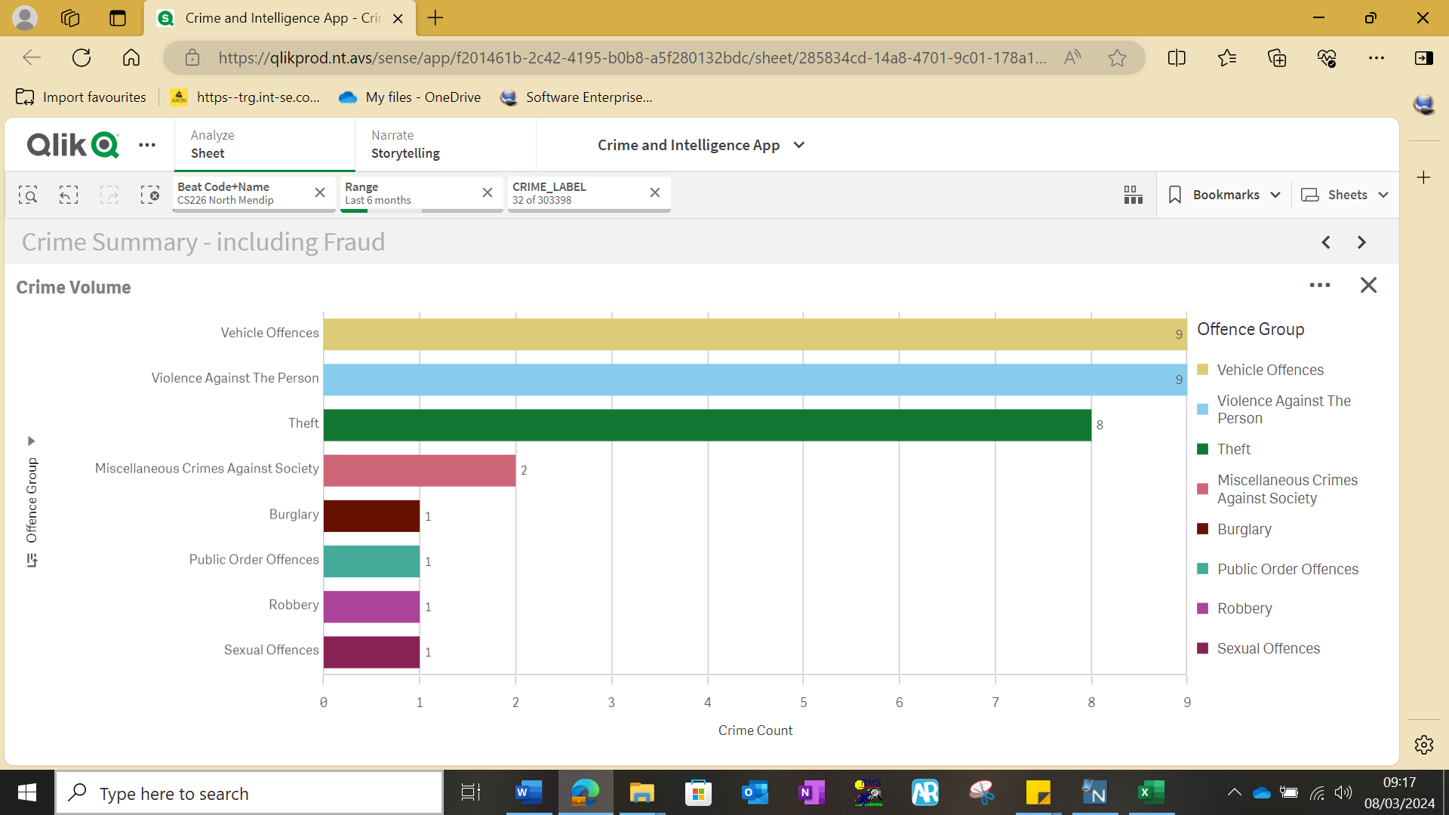

There was a total of 32 offences reported in this 6 month period. The reports were made by direct contact to the police by using 999 , 101 or E-mail.

Violence Against the Person = 9. This offence group includes physical assaults, Assault on an emergency worker, harassment, controlling or coercive behaviour and stalking.
Theft = 8. This covers, making off without payment (bilking).
Arson and Criminal Damage = 0. This offence group included damage to a vehicles and damage to other.
Vehicle Offences = 9. This includes thefts from vehicles & thefts of vehicles.
Public Order Offences = 1. These offences included verbal abuse, threats of violence.
Burglary = 1. This offence group includes residential break in’s and commercial property.
Sexual offences = 1.
Robbery = 1.
Possession of weapons = 0. Possession of firearms or ammunition without a licence.
Miscellaneous Crimes Against Society = 0.

Anti-Social Behaviour (ASB) Statistics for Past 6 Months
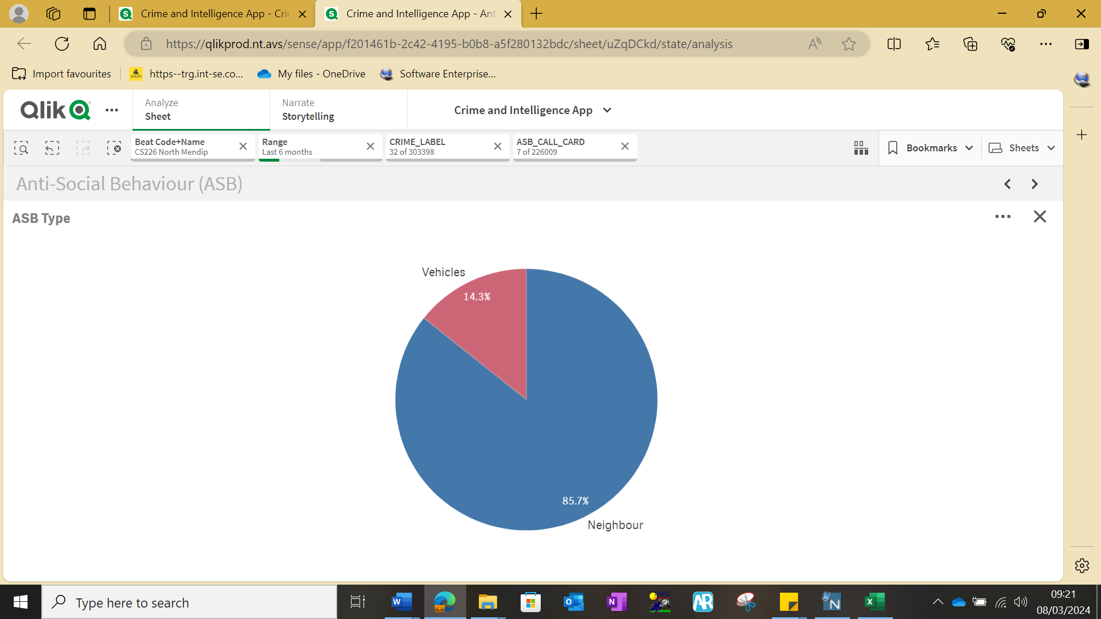
There were 7 incidents classified as ASB. These reports can often be duplicates of crimes that have been reported, where in addition to being a crime the incident is also ASB related. The ASB classification covers a variety of incidents, including nuisance behaviour, neighbour disputes, highway disruption, and road traffic related offences.

Current crime trends in the local area
There has been an increase in theft from workers vans along the A37 and surrounding villages. Unknown persons have been drilling the locks on vans overnight so they can gain access to the tool stored within.
Any questions or points raised in relation to the report please feel free to contact me.
Neighbourhood Beat Team Details
Sgt 432 Lee Humphreys, PS 2485 Rich Newman and PCSO Supervisor 7270 Katie Allwood Coppin - Supervisors
PC 3806 Ross Cudd: Covering the areas of Chew Magna, Chew Stoke, Stowey Sutton, Publow with Pensford, Ubley, Compton Martin, Nempnett Thrubwell, Stanton Drew, and Norton Malreward.
PCSO 8079 Martyn Bragg: Covering the areas of Chew Magna, Chew Stoke, Stowey Sutton, Publow with Pensford, Ubley, Compton Martin, Nempnett Thrubwell, Stanton Drew, and Norton Malreward.
PCSO 9973 Chris Purvey: Covering the areas of Chew Magna, Chew Stoke, Stowey Sutton, Publow with Pensford, Ubley, Compton Martin, Nempnett Thrubwell, Stanton Drew, and Norton Malreward.
PC Stephen Carey 4297: Covering the areas of Farmborough, Clutton, Temple Cloud, Cameley, Hinton Blewett and East & West Harptree, Farrington Gurny.
PCSO Jessica Comer 8477: Covering the areas of Farmborough, Clutton, Temple Cloud, Cameley, Hinton Blewett and East & West Harptre, Farrington Gurney.

